EXP: 1 Write JAVASCRIPT program to validate the following field of a HTML registration page
DATE: 23/01/26

AIM:
To write JAVASCRIPT code to validate user input in a registration form. The validation will ensure that the data entered by the user meets specific criteria for each field. This will help in maintain data integrity and prevent invalid submission.
ALGORITHM FOR LOGIN PAGE:

Step 1:
Start

Step 2:
Create an HTML page with title “Login - Attendance System”.

Step 3:
Design the login form using:
- Username field
- Password field
- Login button

Step 4:
When user clicks Login button, call loginValidate() function.

Step 5:
In JavaScript function:
- Read username and password using getElementById().

Step 6:
Check if username or password is empty.
- If empty → Display alert “All fields are required”.
- Stop execution.

Step 7:
Check if:
- Username = "admin"
- Password = "123456"

Step 8:
If correct:
- Display “Login Successful”
- Redirect to index.html using window.location.href.

Step 9:
If incorrect:
- Display alert “Invalid Username or Password”.

Step 10:

Stop

ALGORITHM FOR REGISTRATION PAGE:
Step 1:

Start

Step 2:
Create an HTML page with registration form fields:
- First Name
- Last Name
- Password
- Email
- Mobile Number
- Address

Step 3:
When user clicks Register button, call validateForm() function.

Step 4:
Read all input values using:
document.forms["regForm"].

Step 5:
Define validation patterns:
- Name → Alphabets only
- Email → Standard pattern (name@domain.com)
- Mobile → 10 digits only

Step 6:
Check First Name:
- Must contain only alphabets
- Must be minimum 6 characters
If not valid → Show alert and stop.

Step 7:
Check Password:
- Must be at least 6 characters
If not valid → Show alert and stop.

Step 8:
Check Email:
- Must follow proper email format
If invalid → Show alert and stop.

Step 9:
Check Mobile Number:
- Must contain exactly 10 digits
If invalid → Show alert and stop.

Step 10:
Check Last Name and Address:
- Must not be empty
If empty → Show alert and stop.

Step 11:
If all validations are correct:
- Display “Registration Successful”.

Step 12: Stop

CODE FOR REGISTRATION PAGE:
<!DOCTYPE html>
<html>
<head>
<title>Registration - Attendance System</title>
<style>
body{
font-family: 'Segoe UI';
background: linear-gradient(135deg,#4e73df,#1cc88a);
display:flex;
justify-content:center;
align-items:center;
height:100vh;
}
.form-box{
background:white;
padding:30px;
width:350px;
border-radius:15px;
box-shadow:0 8px 20px rgba(0,0,0,0.2);
}
h2{
text-align:center;
color:#002147;
}
input, textarea{
width:100%;
padding:8px;
margin:8px 0;
border-radius:8px;
border:1px solid #ccc;
}
button{
width:100%;
padding:10px;
background:#4e73df;
color:white;
border:none;
border-radius:8px;
cursor:pointer;
}
button:hover{
background:#1cc88a;
}
</style>
<script>
function validateForm(){
var fname = document.forms["regForm"]["fname"].value;
var lname = document.forms["regForm"]["lname"].value;
var password = document.forms["regForm"]["password"].value;
var email = document.forms["regForm"]["email"].value;
var mobile = document.forms["regForm"]["mobile"].value;
var address = document.forms["regForm"]["address"].value;
var namePattern = /^[A-Za-z]+$/;
var emailPattern = /^[^ ]+@[^ ]+\.[a-z]{2,3}$/;
var mobilePattern = /^[0-9]{10}$/;
if(!namePattern.test(fname) || fname.length < 6){
alert("First Name must contain only alphabets and minimum 6 characters");
return false;
}
if(password.length < 6){
alert("Password must be at least 6 characters");
return false;
}
if(!emailPattern.test(email)){
alert("Enter valid Email ID (name@domain.com)");
return false;
}
if(!mobilePattern.test(mobile)){
alert("Mobile number must be exactly 10 digits");
return false;
}
if(lname == "" || address == ""){
alert("Last Name and Address cannot be empty");
return false;
}
alert("Registration Successful!");
return true;
}
</script>
</head>
<body>
<div class="form-box">
<h2>Registration</h2>
<form name="regForm" onsubmit="return validateForm()">
<input type="text" name="fname" placeholder="First Name">
<input type="text" name="lname" placeholder="Last Name">
<input type="password" name="password" placeholder="Password">
<input type="text" name="email" placeholder="Email">
<input type="text" name="mobile" placeholder="Mobile Number">
<textarea name="address" placeholder="Address"></textarea>
<button type="submit">Register</button>
</form>
</div>
</body>
</html>
CODE FOR LOGIN PAGE:
<!DOCTYPE html>
<html>
<head>
<title>Login - Attendance System</title>
<style>
body{
font-family:'Segoe UI';
background:linear-gradient(135deg,#4e73df,#1cc88a);
display:flex;
justify-content:center;
align-items:center;
height:100vh;
}
.login-box{
background:white;
padding:40px;
width:320px;
border-radius:15px;
box-shadow:0 8px 20px rgba(0,0,0,0.2);
text-align:center;
}
h2{
color:#002147;
}
input{
width:100%;
padding:10px;
margin:10px 0;
border-radius:8px;
border:1px solid #ccc;
}
button{
width:100%;
padding:10px;
background:#002147;
color:white;
border:none;
border-radius:8px;
cursor:pointer;
}
button:hover{
background:#1cc88a;
}
</style>
<script>
function loginValidate(){
var username = document.getElementById("username").value;
var password = document.getElementById("password").value;
if(username=="" || password==""){
alert("All fields are required");
return false;
}
// Simple static login (for experiment purpose)
if(username=="admin" && password=="123456"){
alert("Login Successful!");
window.location.href="index.html";
return false;
}
else{
alert("Invalid Username or Password");
return false;
}
}
</script>
</head>
<body>
<div class="login-box">
<h2>Login</h2>
<form onsubmit="return loginValidate()">
<input type="text" id="username" placeholder="Username">
<input type="password" id="password" placeholder="Password">
<button type="submit">Login</button>
</form>
<br>
<a href="registration.html">New User? Register Here</a>
</div>
</body>
</html>

OUTPUT:

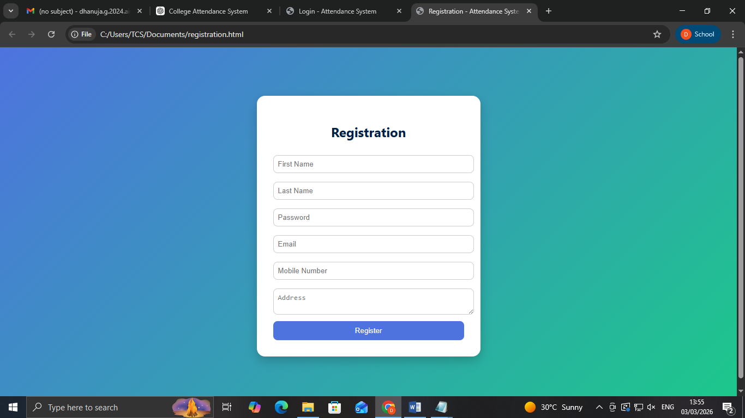

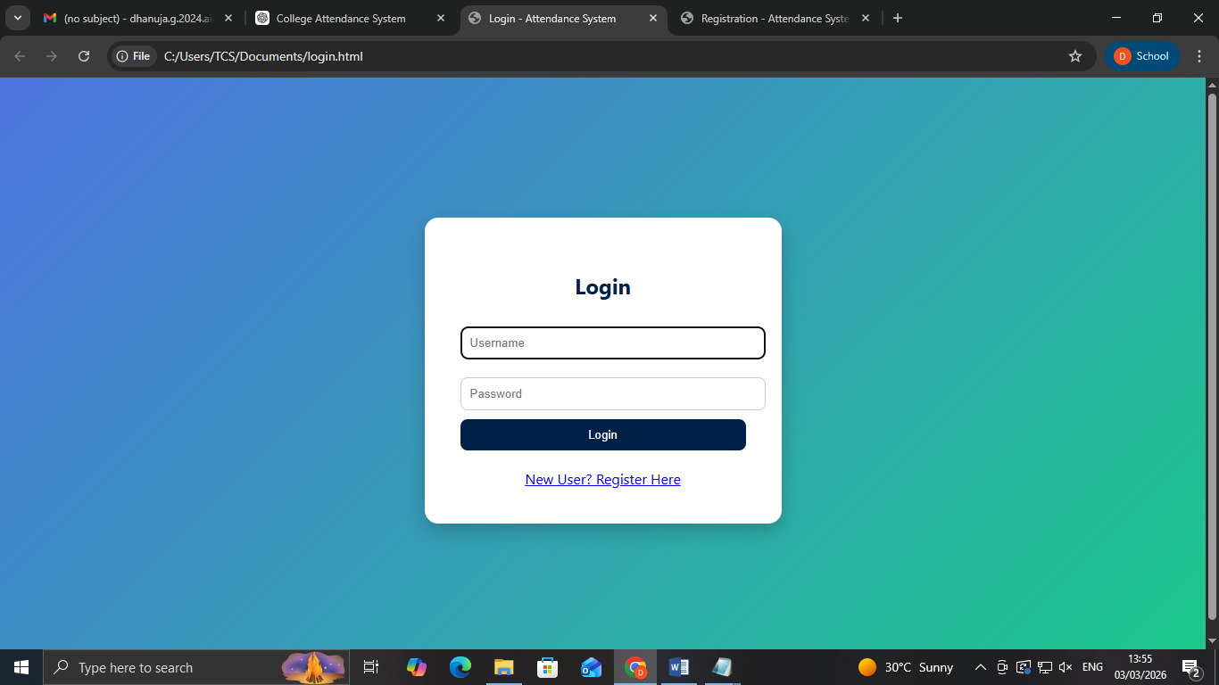

RESULT:
HTML page with form is created and is validated using JAVASCRIPT.

